3BA1 tutorial 3

Theorem of Total Probability ,(Partition law) , Bayes’ Theorem.

Consider the following simple version of digit recognition software.

An image of a number is processed to ascertain the numerical value

The properties of the recognition algorithm are as follows.

‘1’ and ‘7’ are some times confused

 |  | Read as
 | TRUE | 1' | 7'
 | 1' | 0.95 | 0.05
 | 7 | 0.02 | 0.98

Suppose all other digits are correctly identified with probability 1.

1.If the true value is equally likely to be any digit in the range 0 to 9 what is the probability that:
- That it is concluded that the number is a 7.
- That the digit is correctly read
- If a 1 is reported that the actual digit is a ‘1’

2.What is the probability that the two digit number 17 is correctly identified.

3. 181 is reported what could have been the real number and with what probability?
Here it is also know that there is only a 20% chance that the number exceeds 499 (equally likely otherwise)
Solution
(a) P(report 7) =

0.98 * 0.1 + 0.05 *0.1 + 0 *0.8
=0.098 +0.005 + 0 = 0.103

(b) P(Correct) = P(correct|7)* P(7) + P(correct|1)*P(1) + P(correct|other)*P(other)
0.98*0.1 + 0.95 * 0.1 + 1 * 0.8

= 0.098 + 0.095 + 0.8 = 0.993
= 1-P(error) = 1 – (0.05*0.1 +0.02*0.1)

(c) 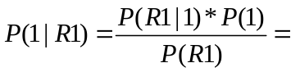
P(R1) = 0.02*0.1 +0.95*0.1+ 0 = 0.097

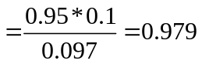

2. Assume independent processing
P(17 correct) =P(1 correct) * P(7 correct) = 0.95*0.98 =0.931

3.The 8 must be correct but the others could be 1s or 7s. so we could have:
181, 187, 781 , 787
0.0016 0.0016 0.0004 0.0004
Each number 0..499 has chance 0.0016 * 500 = 0.8
500..999 0.0004*500 = 0.2
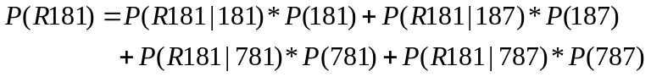

P(R181|181) =0.95*0.95 =0.9025 2x1 and an 8 correct ( * 0.0016)
P(R181|187) =0.95*0.02= 0.0190 ( * 0.0016)
P(R181|781)=0.02*0.95 =0.190 (*0.0004)
P(R181|787)=0.02*0.02=0.0004 (*0.0004)
 |  | /10000 | Ci
181 | 0.9025 | 16 | 14.44
187 | 0.019 | 16 | 0.304
781 | 0.019 | 4 | 0.076
787 | 0.0004 | 4 | 0.0016
P(R181)= 14.816/10000
P(X|R181) = Ci/14.816
Conclusions:
Prob | Value
0.974254 | 181
0.020511 | 187
0.005128 | 781
0.000108 | 787

